**Capstone Project - The Battle of Neighborhoods**

# Table of contents

1. Part 1 - Introduction: Business Problem
2. Part 2 - Data Section
3. Part 3 - Methodology
4. Part 4 - Analysis
5. Part 5 - Results
6. Part 6 - Conclusion

# Part 1 - Introduction: Business Problem

Imagine that you are a traveller who loves Japanese food. And, you you will visit NY city and Toronto in the upcoming days. This study will allow you to find the city holding the major number of Japanese restaurants.

Or... imagine that you are a highly skilled sushiman wanting to move over and work in a big city in North America. You want to know what city you will find more job work opportunities as a sushiman.

It is well known that both New York and Toronto cities have a large number of immigrants and, by using this study we will be able to identify what city has more japanese restaurants. And, besides immigrants, local people may like japanese food also and this way justify the number of japanese restaurants.

So, in summary, the goal of this study is to identify in what city you will find more opportunities to find a japanese restaurant. Besides the numbers, it will be provided additional information and maps to justify the chosen city. Of course, this study reflects current information and it may be used in the future to get more updated information.

## Business goal

The goal of this study is to identify between New York and Toronto cities, where you are most likely to find Japanese restaurants. This study may be useful for travellers (that like japanese food of course) as well as sushimen professionals trying to find the best city to live and work. For them, the more japanese restaurants in the city, more job opportunities they will have.

## Target Audience

This study may be used by anyone interested in Japanese food. No matter if you are a local, traveller or a sushiman looking for a new job and a new city to work.

# Part 2 - Data Section

Following data sources will be used to get the required information:

1. Wikipedia will be used scrap Toronto and New York neighborhoods;
2. Geocoder will be used to get Latitude and Longitude information;
3. Foursquare API will be used to get restaurants data related to these 2 cities.

Above data sources will be used to get venues and japanese restaurants information in order to identify in what city we have more Japanese restaurants and, this way, more opportunities for travellers and professionals.

## Data flow

1. First, it is used data from get_city_opendata to get cities information as well as latitude and longitude coordinates
2. Then, for both New York and Toronto cities, it is created two dataframes with borough and neighbourhood information. For Toronto, it is used Wikipedia to get the list of Postal Code of all Neighbourhoods in Toronto
3. And. for every neighbourhood in both dataframes, it will be gathered the list of restaurants from Foursquare. With this information it is possible to come up with a total as well as draw the maps with japanese restaurants location.

# Part 3 - Methodology

The goal of this project is to come up with a simple study to identify between 2 of the biggest cities in the world, which one have more japanese restaurantes and, this way, more job market for japanese-food professionals as well as travellers that love japanese food. The main idea is to know the boroughs and neighbourhoods of both cities, New York and Toronto, and in the sequence, for each neighbourhood, this study will identify all japanese restaurants.

After that, it will be presented some number to justify the decision about what city has a better job market and more offers for travellers wishing to have good time with delicious japanese plates.

And finally, in the last part of this study, it is showed two maps showing the spots where these japanese restaurants are located. These maps have the full address and this way it is easier for anyone to quick spot where to find those restaurants.

# Part 4 - Analysis

First, it is identified some basic geogrpahic info from the two cities.

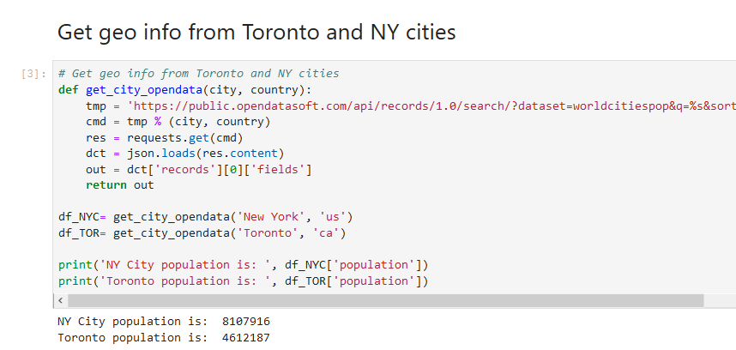

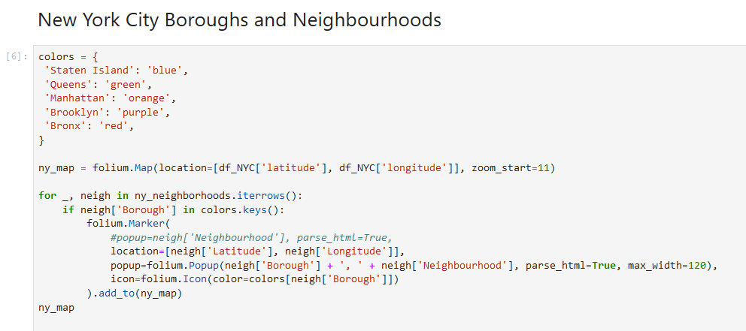

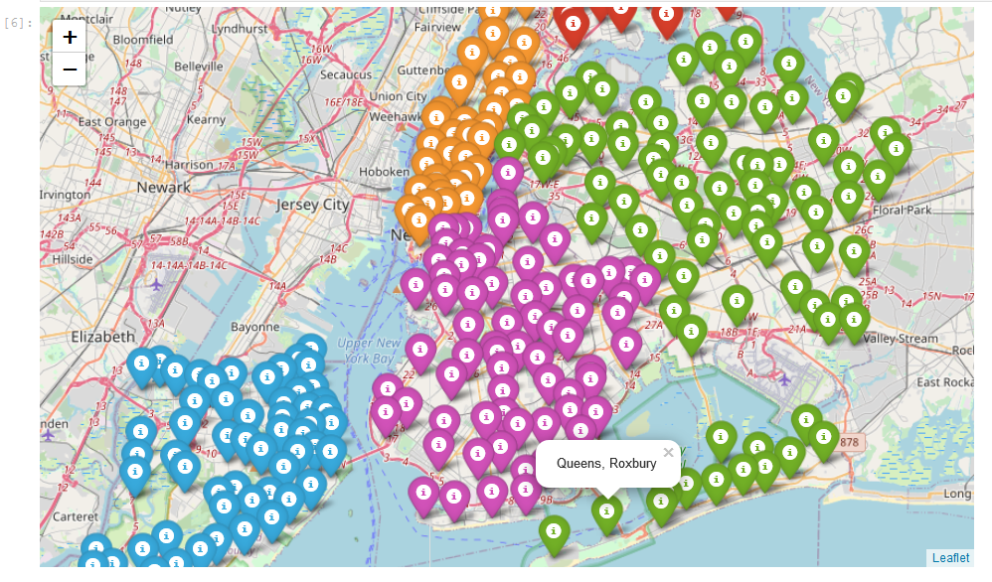

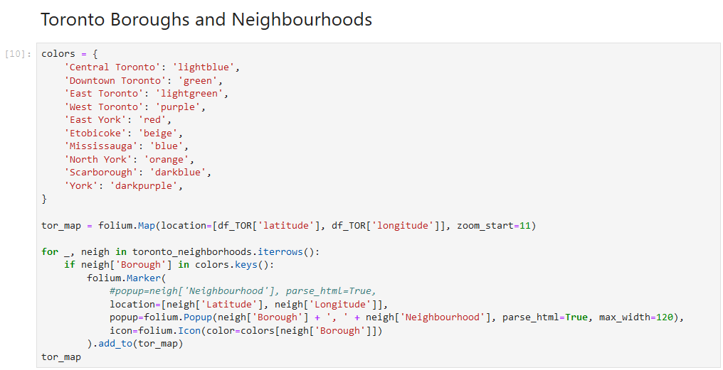

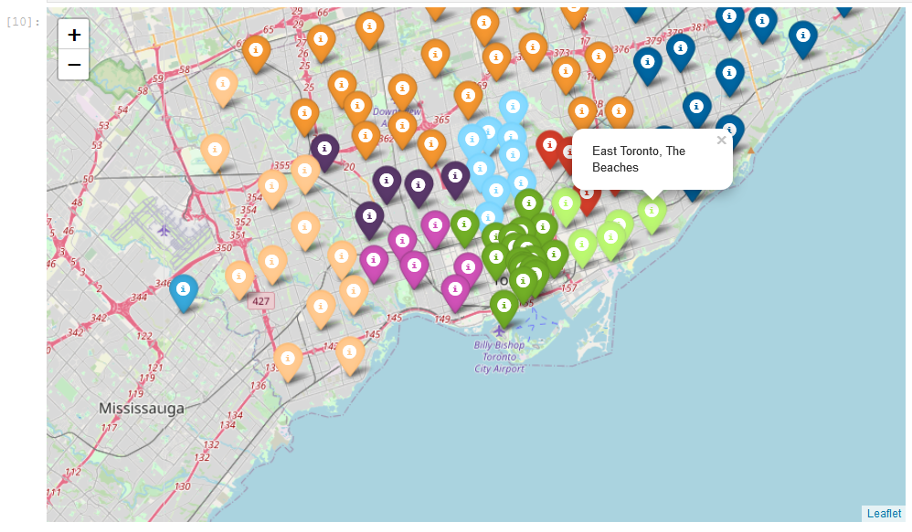

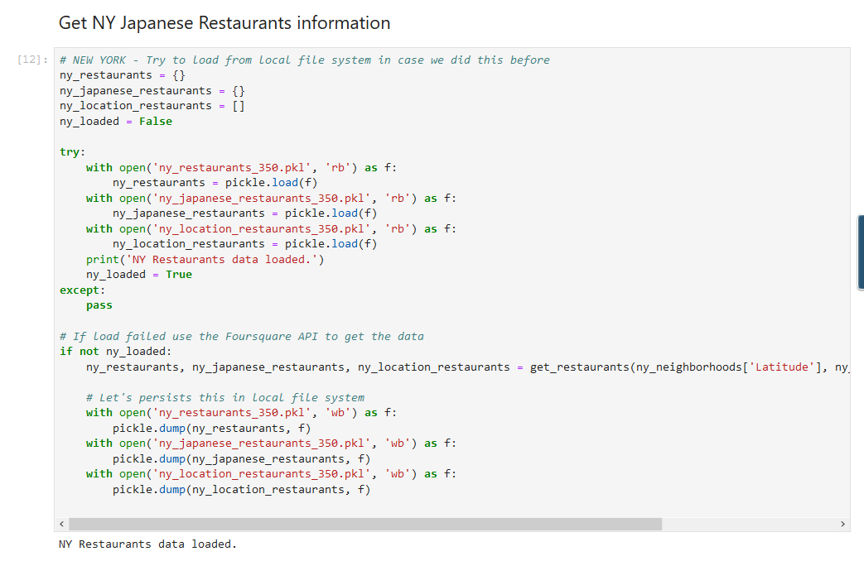

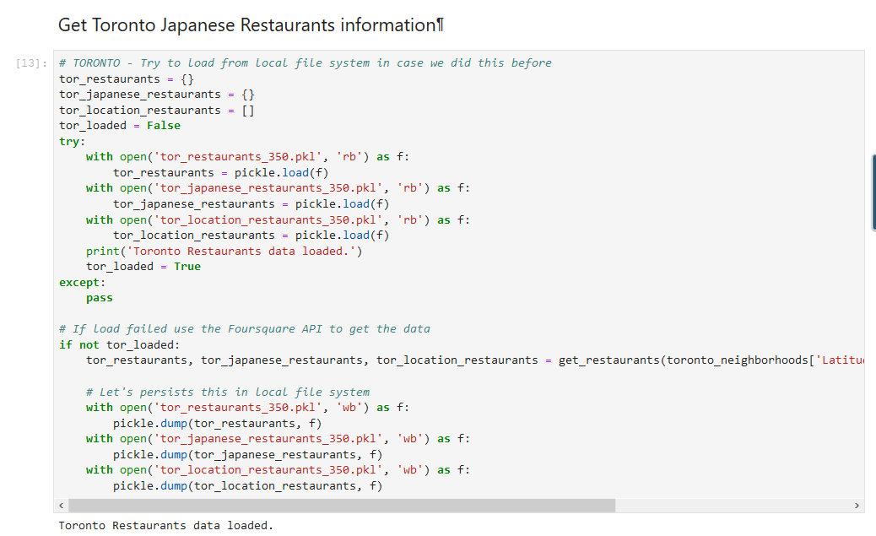

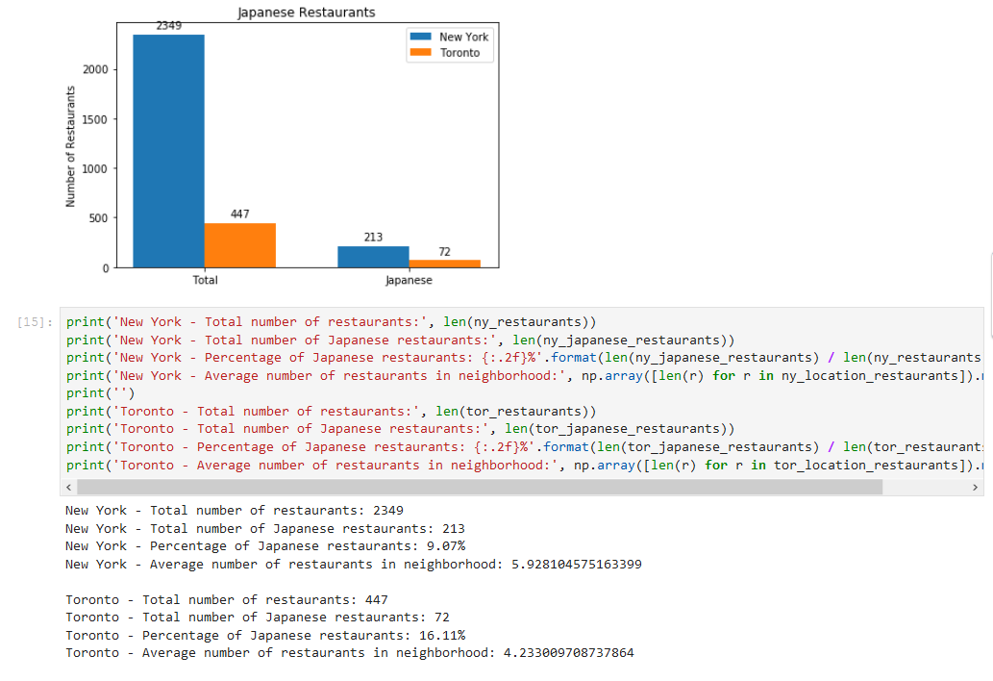

# Part 5 - Results

By looking the numbers and the chart above, it is clear that New York city has more japanese restaurants than Toronto. And, we can also verify that New York has also more restaurants, in despite of the restaurant category.

So, if you are a japanese-restaurant professional like a sushiman, it is more likely for you to find a job in New York city than Toronto. Of course, this study focused only in the number of japanese restaurants and it doesn't take in account another factos that may influence the chance of someone get a job or not or even get work VISA or not.

# Part 6 - Conclusion

And now this study comes to a conclusion where is was showed that New York city has more japanese restaurants than Toronto. And by consequence a more robust marketplace for restaurants under this japanese category as well as more opportunitis for travellers and local people to enjoy the fantastic japanese food.

But this study would not be complete if it was not listed all these restaurants in both cities. So, in tis last part of this study, it is presented two maps with markers showing all restaurants identified in this study. By clicking in the mark, you can see the restaurant name as well as its address.

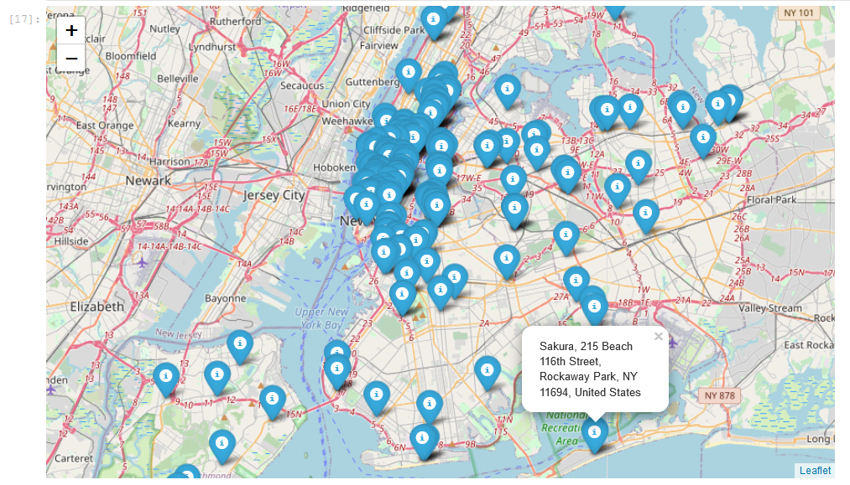

Above picture: Japanese restaurants in New York city..

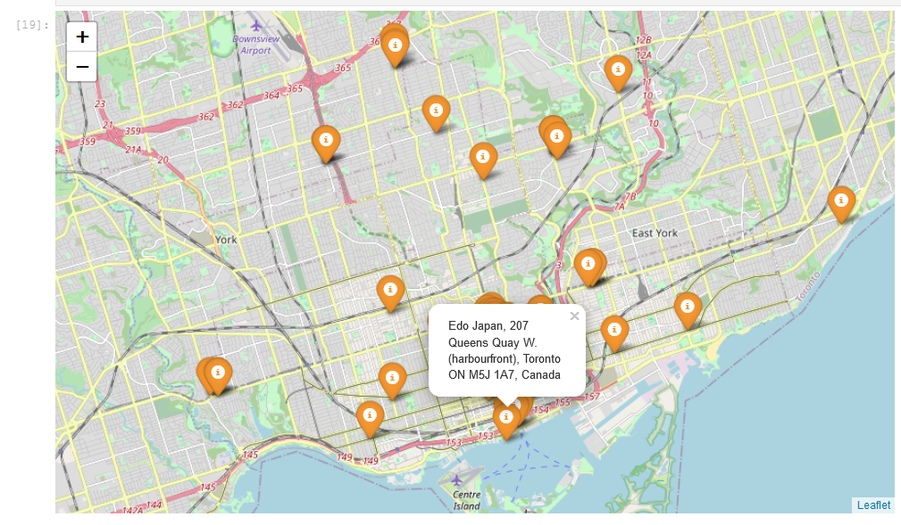

Above picture: Japanese restaurants in Toronto.